**GitHub Account**

Got to GitHub and sign up for an account. <https://github.com/>

**Note:** Remember to use the same e-mail address you used in the Git config.

**Create a Repository on GitHub**

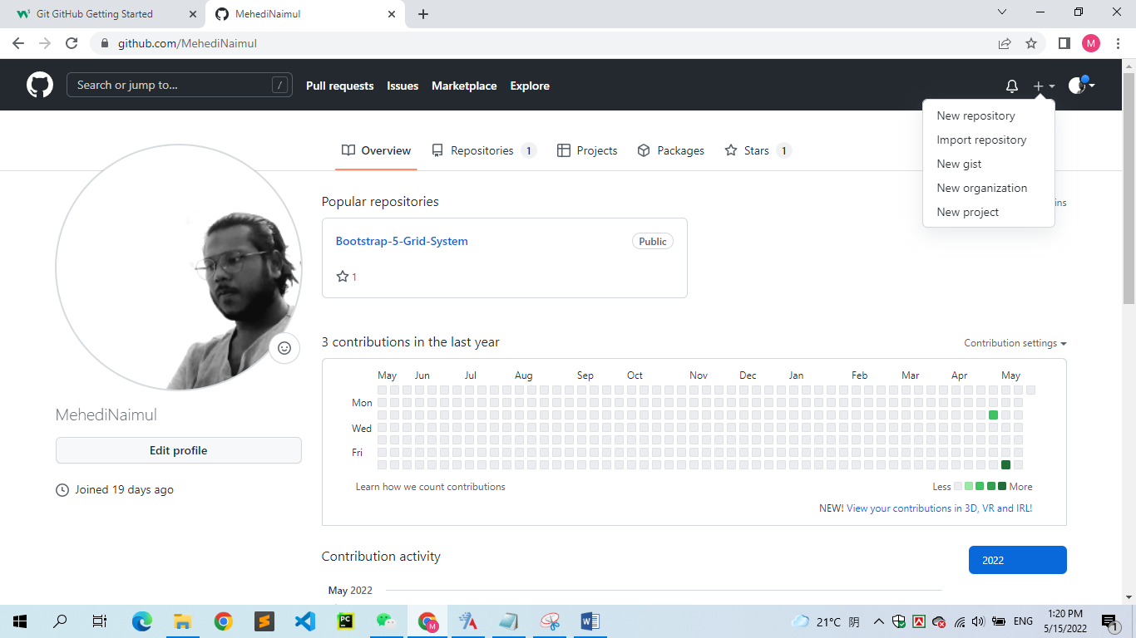

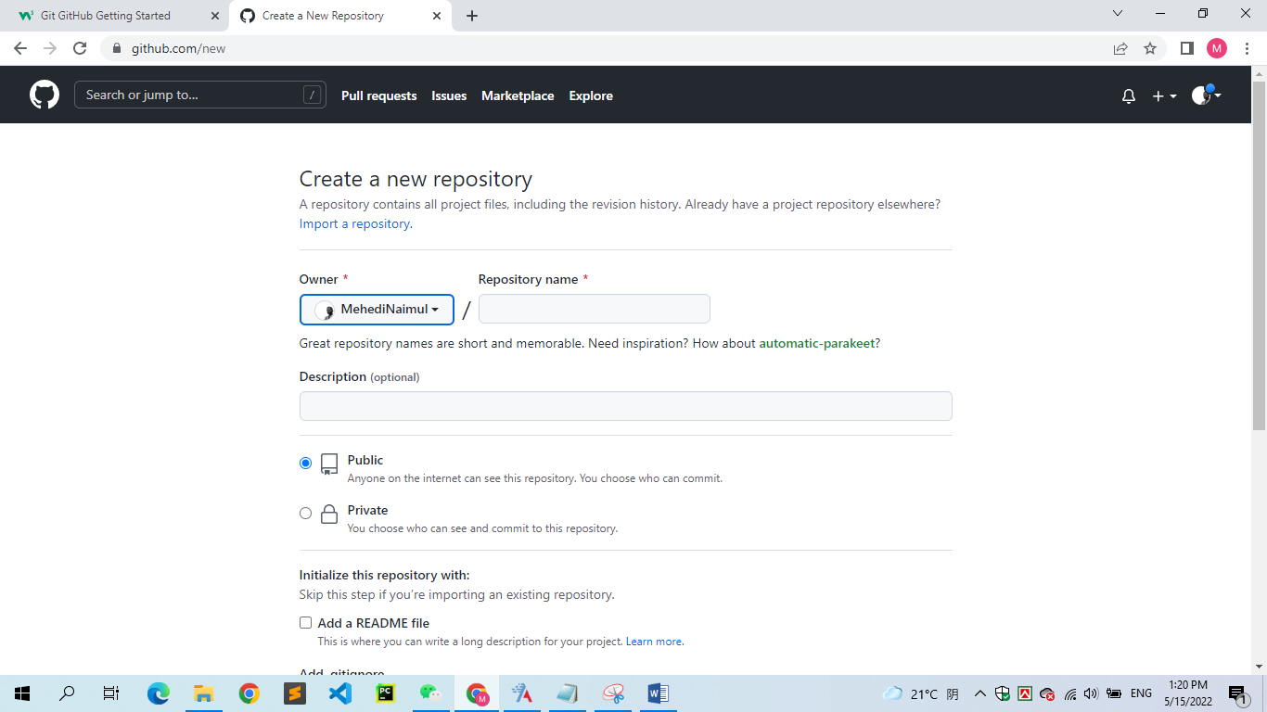

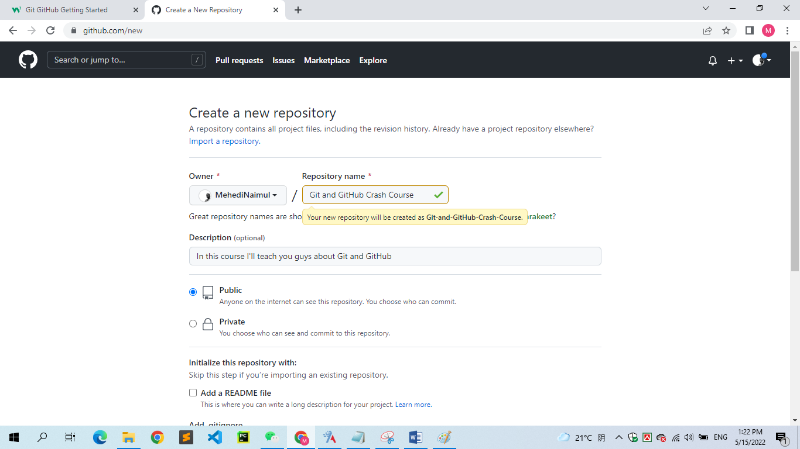

Choose Public (if you want to repo to be viewable for anyone) or Private (if you want to choose who should be able to view the repo). Either way, you will be able to choose who can **contribute** to the repo.

Then click “Create repository”.

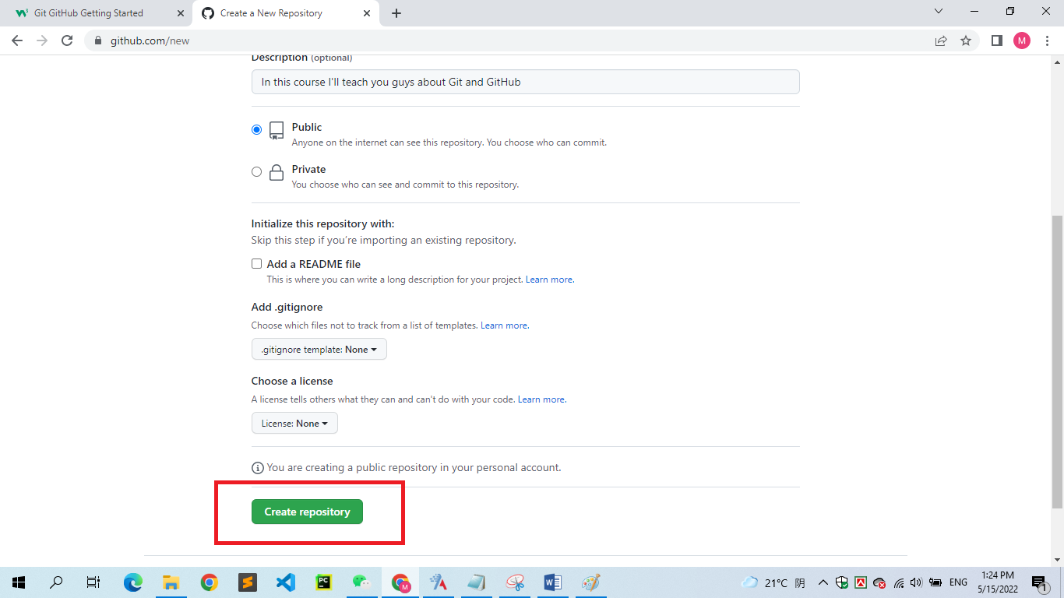

**Push Local Repository to GitHub**

Since we have already set up a local Git repo, we are going to *push* that to GitHub

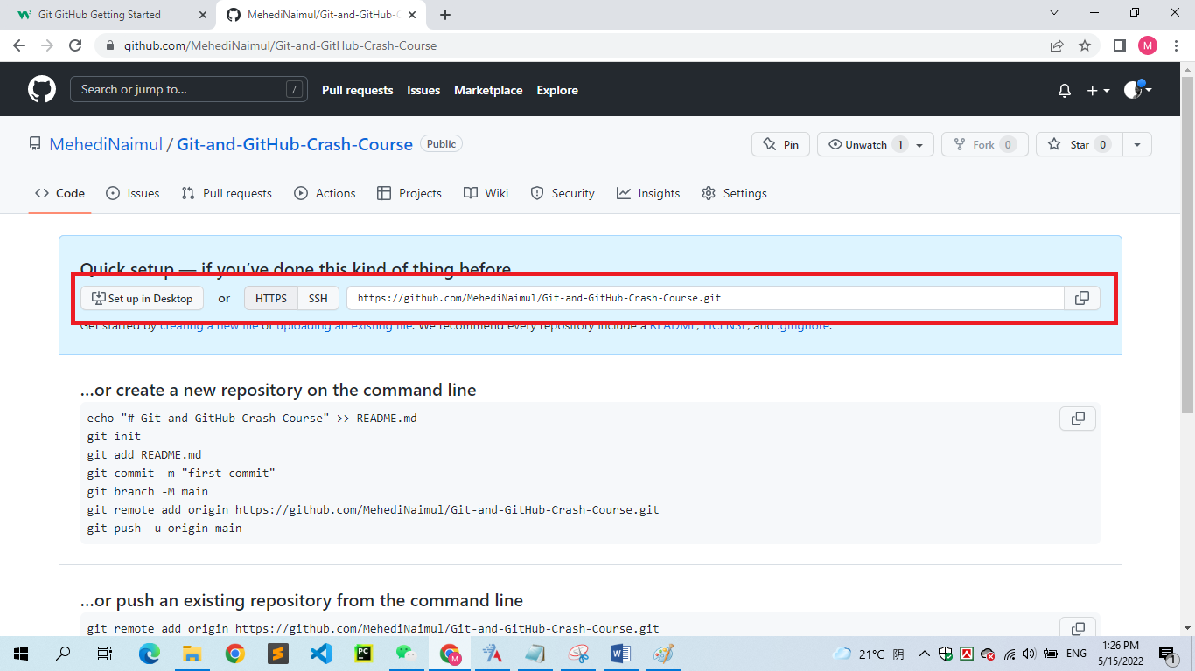

Copy that URL, or click the clipboard.

Now paste it the following command:

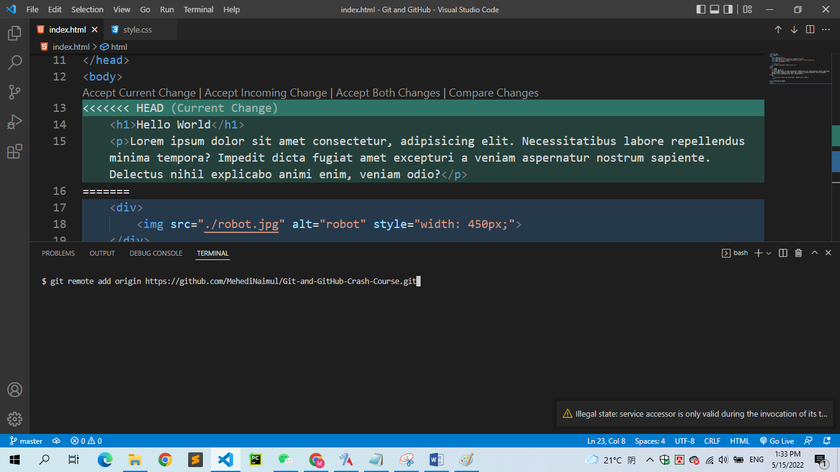

*git remote add origin URL* specifies that you are adding a remote repository, with the specified URL, as an *origin* to your local Git repo.

Now we are going to push our master branch to the origin url, and set it as the default remote branch:

